REROUTE ADVISORY: Route #1 Joseph E Lowery Blvd/17th. Street, 7 Boulevard/McDonough Boulevard, 68 Donnelly Ave/Beecher, 71 Cascade Road, 81 Venetian Hills, and #95 Metropolitan Parkway
WHAT: MPD 2026 Full Scale Exercise
WHERE: West End Station
WHEN: Saturday, April 25, 2026
TIMES: 10:00 PM – 3:00 AM
Reroute as follows:
INBOUND: Route #1 from West End Station to Arts Center Station
Continue W Whitehall St
(Begin Reroute)
Continue Lee St
Right – Campbellton Rd
Left – into Oakland City Station
Proceed to the drop-off location. After the drop-off is complete, circle the bus loop to stage in the middle lane.

OUTBOUND: Route #1 from Arts Center Station to West End Station
(Begin Reroute)
Exit Station
Right – Campbellton Rd
Left – Lee St
Continue left for Lee St (MARTA Underpass)
Regular Route

INBOUND: Route #7 from West End Station to Lindbergh Station
(Begin Reroute)
Exit Station
Right – Campbellton Rd
Left – Lee St
Continue left for Lee St (MARTA Underpass)
Regular Route

OUTBOUND: Route #7 from Lindbergh Station to West End Station
Continue W Whitehall St
(Begin Reroute)
Continue Lee St
Right – Campbellton Rd
Left – into Oakland City Station
Proceed to the drop-off location. After the drop-off is complete, circle the bus loop to stage in the middle lane.

INBOUND: Route #68 from Beecher Road to West End Station
Continue Donnelly Ave
(Begin Reroute)
Right – Lee St
Right – Campbellton Rd
Left – into Oakland City Station
Proceed to the drop-off location. After the drop-off is complete, circle the bus loop to stage in the middle lane.

OUTBOUND: Route #68 From Ashby Station to H.E Holmes Station
(Begin Reroute)
Exit Station
Right – Campbellton Rd
Left – Lee St
Left – Donnelly Ave
Regular Route

INBOUND: Route #71 from Boat Rock to West End Station
Continue W Whitehall St
(Begin Reroute)
Continue Lee St
Right – Campbellton Rd
Left – into Oakland City Station
Proceed to the drop-off location. After the drop-off is complete, circle the bus loop to stage in the middle lane.

OUTBOUND: Route #71 from West End Station to Boat Rock
(Begin Reroute)
Exit Station
Right – Campbellton Rd
Left – Lee St
Continue left for Lee St (MARTA Underpass)
Regular Route

INBOUND: Route #81 from East Point Station to West End Station
Continue Oglethorpe Ave
(Begin Reroute)
Right – Lee St
Continue right for Lee St
Right – Campbellton Rd
Left – into Oakland City Station
Proceed to the drop-off location. After the drop-off is complete, circle the bus loop to stage in the middle lane.

OUTBOUND: Route #81 from West End Station to East Point Station
(Begin Reroute)
Exit Station
Right – Campbellton Rd
Left – Lee St
Continue left for Lee St (MARTA Underpass)
Left – Oglethorpe Ave
Regular Route

INBOUND: Route #95 from Trinity Towers to West End Station
Continue W Whitehall St
(Begin Reroute)
Continue Lee St
Right – Campbellton Rd
Left – into Oakland City Station
Proceed to the drop-off location. After the drop-off is complete, circle the bus loop to stage in the middle lane.

OUTBOUND: Route #95 from West End Station to Trinity Towers
(Begin Reroute)
Exit Station
Right – Campbellton Rd
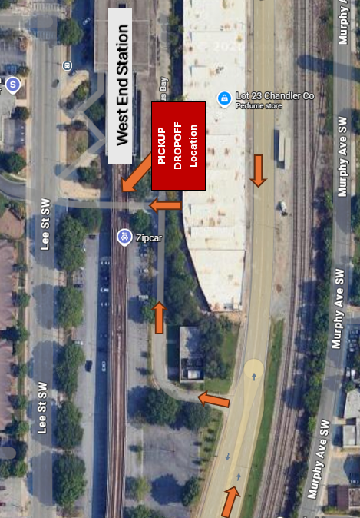
Left – Lee St
Continue left for Lee St (MARTA Underpass)
Regular Route

